Procurement Tracker

From our recent ideas, camera, GPS, wave radiation is some possible stuff that we may order for this project

Project Budget

Our design budget is 150 from Myfab

We need to contact with stakeholders for how much money they want to spend on finding sheep

How much money they can gain from one sheep

How often the sheep lost

How many sheep usually lost

The budget cannot exceed their earning for every year since they want to make money from sheep

We need to lower the cost to a minimum and use environmentally friendly materials on this project to protect environment

There are 120-150 sheep so we have two options of designs, first one is to provide a product for each sheep, this needs to lower the single price to a minimum since that will be a large number when multiply 150. The second one is that the product is designed for the whole group of sheep, for this situation, we can use all money on one product, and this is more flexible since we do not need to separate the budget into 150 parts.

Our final design is GSM GPS tracker

The list of components that we need to build the tracker:

1. Maduino Zero GPRS/GPS A9G $28.8

<https://makerfabs.com/maduino-zero-a9g.html>

Combining of GPS, GMS, and microcontroller

1. Battery $7.95

<https://www.adafruit.com/product/1578?gclid=Cj0KCQiAmpyRBhC-ARIsABs2EAodqU4qGBYFjfZwkBEXiGZp6y4T17TXWyLDgFYAOGJ4r4BmeVq60qUaAkMnEALw_wcB>

3.7V Lithium-Ion Battery

1. USB cable $9.98

<https://www.amazon.com/gp/product/B01JPDTZXK/ref=as_li_tl?ie=UTF8&camp=1789&creative=9325&creativeASIN=B01JPDTZXK&linkCode=as2&tag=shophow2elect-20&linkId=75ac7e40e038c335e3850943fff350bd>

1. Humidity sensor (We do not exactly need) $10.29

<https://www.amazon.com/gp/product/B01DKC2GQ0/ref=as_li_tl?ie=UTF8&camp=1789&creative=9325&creativeASIN=B01DKC2GQ0&linkCode=as2&tag=shophow2elect-20&linkId=ccbd50ca5cb46a6f1c2b805b8d55ce64>

1. OLED $6.99

<https://www.amazon.com/gp/product/B072Q2X2LL/ref=as_li_tl?ie=UTF8&camp=1789&creative=9325&creativeASIN=B072Q2X2LL&linkCode=as2&tag=shophow2elect-20&linkId=545b7a03e142355ea61e61185a811657>

1. Wires
2. 3D print

This is the first option which cost about $75

<https://how2electronics.com/gps-gsm-based-vehicle-tracking-system-using-arduino/>

A much cheaper o

1. SIM808 based board BK-SIM808 (10-12 USD on Aliexpress )
2. search for "[www.and-global.com](http://www.and-global.com/)" boards BK-SIM808 or equivalent (you may try here <http://and-global.en.alibaba.com/> )... <https://cdn.instructables.com/ORIG/FAO/80RU/IXLALERK/FAO80RUIXLALERK.pdf>) it may also work with boards SKU405361-SIM808 (see description below for source code options)
3. GPS (passive) antenna with IPEX / U.FL connector matching BK-SIM808 board - 2 USD
4. GSM antenna with IPEX / U.FL connector matching BK-SIM808 board - 1 USD
5. ATMEGA 328P (arduino uno) - 2 USD or ATMEGA328P based board : <https://www.theengineeringprojects.com/2018/06/introduction-to-arduino-pro-mini.html>
6. XTAL 8MHz - quartz crystal with 8 MHz frequency to ensure clock stability of ATMEGA and keep it synchronized with serial port of SIM808 module even when temperature changes (internal RC oscillator in ATMEGA is very unstable). Using XTAL is optional (compile scripts configure internal RC clock by default ) but i do RECOMMEND using XTAL due to poor internal clock of ATMEGA. This one costs 0.2USD
7. 2 x 22pF capacitor for XTAL - 0.2 USD
8. 3x 1N4007 (1 USD) - to convert 5V from powerbank to 3.3V for ATMEGA328P VCC ( only for BK-808 board and others that require TTL 3.3V logic)
9. 2x 1000uF / 16V capacitor ( 0.5 USD) - connect to VCC & GND of SIM808 board AND to existing 100uF (parallel) on the SIM808 board - usage of this capacitor depends on type of SIM808 board
10. 100nF (or some other in range 100nF-1uF) / 12V (or higher) capacitor (0.2 USD) - connect to VCC & GND of ATMEGA328P ( if not using "Arduino Pro Mini" board)
11. universal PCB, pins & connector (2 USD) or some wires with pins if you going to use boards like "Arduino Pro Mini" instead
12. USB Powerbank 5V to make it work...

Second option, about $30

[Make your own cheap DIY GSM GPS bike car tracker / GPS car locator for 20 USD ! - based on SIM808](https://www.youtube.com/watch?v=8R99t0O52GI&t=1s)

[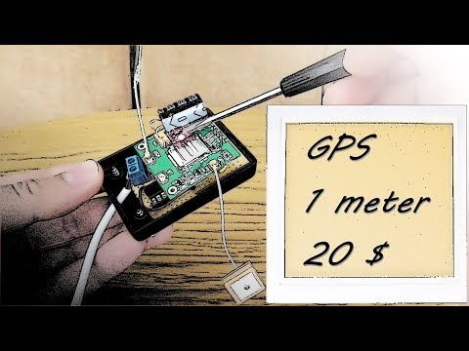](https://www.youtube.com/watch?v=8R99t0O52GI&t=1s)

<https://github.com/mcore1976/sim808gpstracker>

Our budget is far away from $150

List of prices from M

GPS module $5.198

Lihin WIfi $6.888